Configuration of Date, Time, and Timezone in the HTi scale

Use the calendar to set today’s date.

Then set the scale’s time and time zone.

Update the information and press “Set Time” button after you are done.

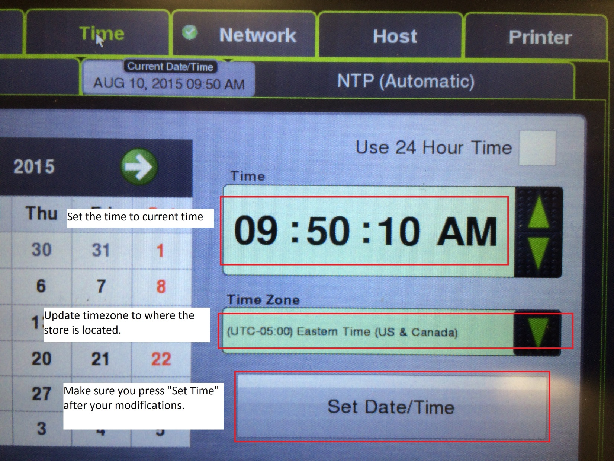

Configuration of Network and DNS Suffix in HTi scale

On the network setup tab, you will need to fill in IP address information based on the scale you are replacing. Wal-Mart follows this convention:

IP address: Duplicate the ip address of the scale you are replacing.
Meat - scale 1 - X.X.X.65 (use this in old store layout only)
Meat - scale 2 - X.X.X.66 (this should be used in 90% of stores)
Deli - scale 4 - X.X.X.68
Deli - scale 5 - X.X.X.69
Deli - scale 6 - X.X.X.70
Deli - scale 7 - X.X.X.71
Deli - scale 8 - X.X.X.72
Produce - scale 10 - X.X.X.74
Bakery - scale 12 - X.X.X.76

Netmask: 255.255.255.0

Gateway: This is the first 3 octets of scale ip followed by 1 (X.X.X.1).

DNS server: This is the first 3 octets of scale ip followed by 129 (X.X.X.129).

After setting the above information, touch the Advanced button.
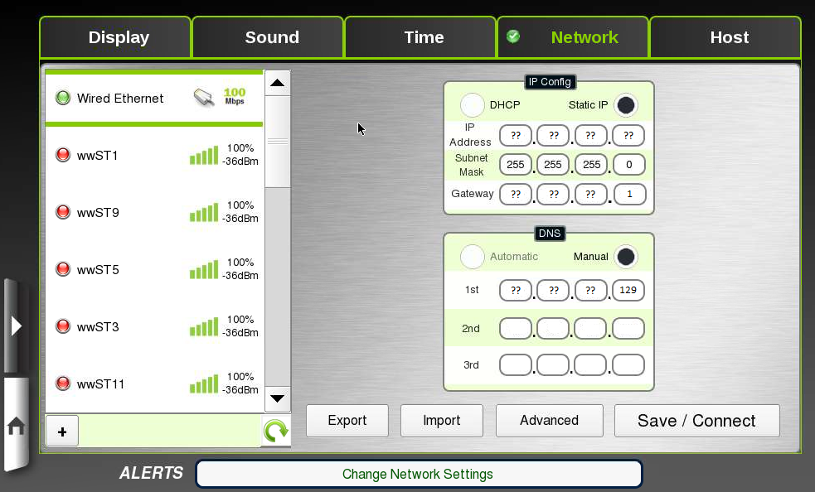

DNS Suffix

The DNS Suffix interface in the Setup Utility is available since HTi version 1.12.705. This enables the scale to reach specific hostnames without having to configure the full name including the domain name.

DNS suffix name conventions for Wal-Mart:

s<store number>.<country code>.<store name>.com

Where:

Store number – a five digit store number with leading zeros, for example: 01410
Country code – us
Store name - it is either ‘wal-mart’ or ‘sams’

Example: s01410.us.wal-mart.com

DNS suffix configuration interface:

- Enter to Supervisor Pages
- Select All functions
- In Miscellaneous touch Setup Utility, the Setup Utility page will show.
- Enter to Network tab, settings will be loaded.
- The following page will show.
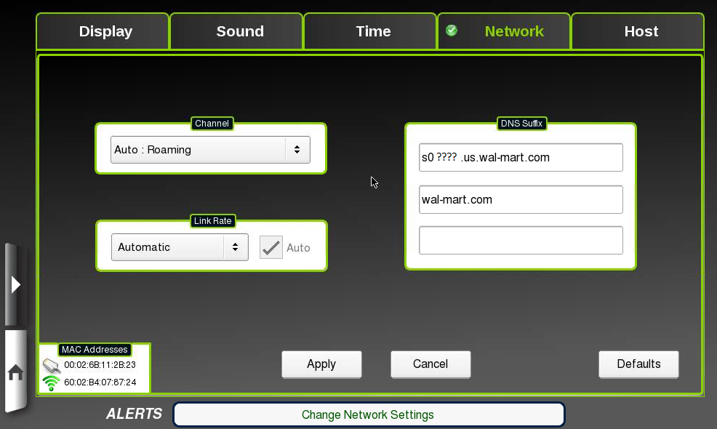

- Enter the DNS suffixes according to the conventions described earlier and press Apply to save and return to the previous page.
- Touch Save / Connect button to save all settings and connect to the network.

Configuration of Hostname in the HTi scale

Hostname will need to be configured for the HTi scale in a Wal-Mart network.

Hostname convention:

scale<scale id>s<store number>us

Where:

Scale id – a two digit scale id
Store number – a five digit store number with leading zeros, for example: 01410

Example: scale16s01410us

